UnlearnX : Real-Time Adaptive Machine Unlearning Framework for Production LLMs
Prepared By: Simar Ahluwalia, Amey Ghatol

1. Executive Summary
As the enterprise adoption of Large Language Models (LLMs) accelerates, strict compliance with data privacy regulations (e.g., GDPR "Right to be Forgotten", CCPA) and intellectual property/copyright mandates has become a paramount operational challenge. Currently, excising specific memorized data from a production model requires either cost-prohibitive full retraining or the application of destructive unlearning techniques that degrade the model's overall intelligence.
UnlearnX proposes a paradigm shift: a real-time, parameter-efficient machine unlearning framework designed for production LLMs. By treating unlearning as a dynamic, hot-swappable inference routing layer rather than a destructive base-weight modification, UnlearnX enables organizations to surgically erase targeted concepts or copyrighted text within seconds. This project will deliver a Proof of Concept (PoC) demonstrating instant compliance capabilities without taking base models offline or sacrificing baseline reasoning performance.

2. Business Problem & Justification
- Regulatory Liability: Foundation models are prone to memorizing sensitive PII or copyrighted text. Retaining this data post-compliance request exposes the enterprise to severe legal and financial penalties.
- Prohibitive Costs: Retraining an LLM from scratch to scrub specific data points costs millions of dollars in compute (GPU hours) and takes weeks to complete.
- Technical Limitations of Current Methods: Existing unlearning methods (e.g., naive gradient ascent) lead to "catastrophic forgetting" (destroying unrelated model capabilities) or "superficial unlearning" (where restricted data can still be extracted via adversarial jailbreaks).

3. Solution Architecture: The UnlearnX Framework
UnlearnX resolves these issues through a proprietary three-stage, parameter-efficient pipeline. Instead of modifying the massive base model, UnlearnX extracts the "unlearned" state into a lightweight Low-Rank Adapter (LoRA).

3.1 High-Level Architecture Flow
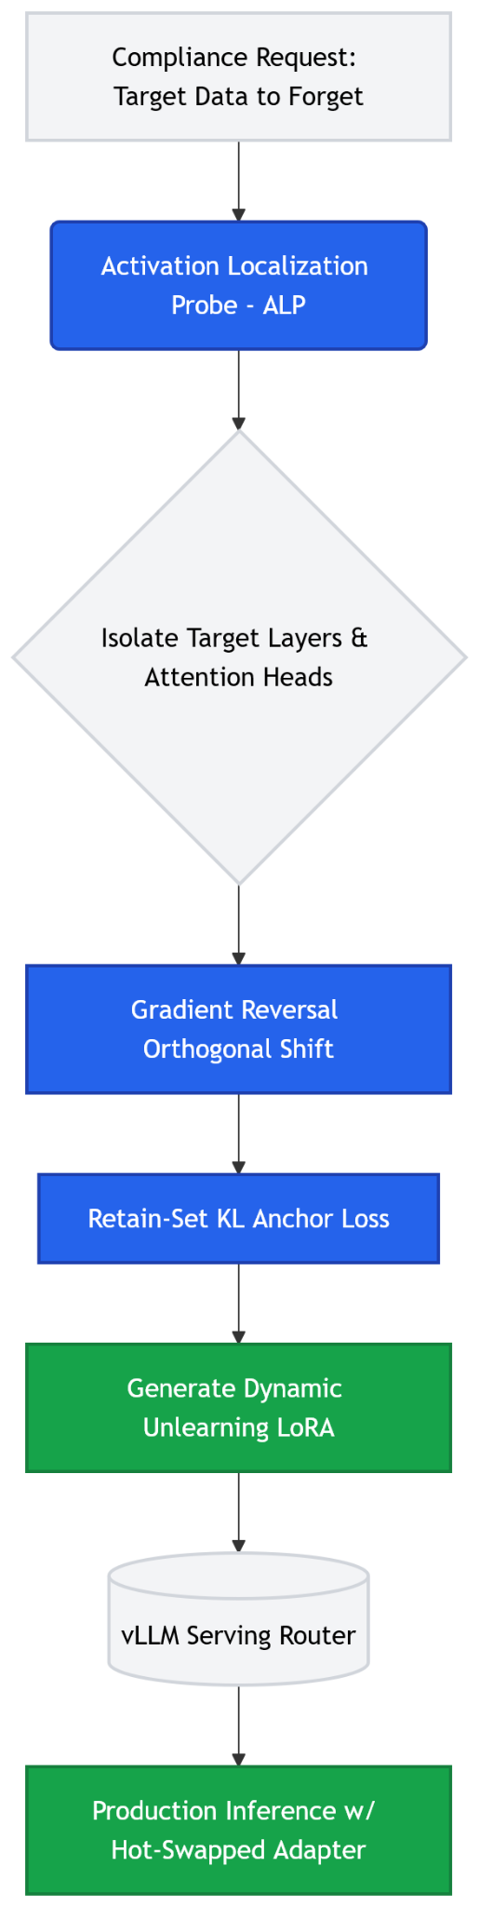

3.2 Core Architectural Components
- Activation Localization Probe (ALP): A monitoring layer that feeds the targeted text into the model and tracks key-value activation clusters. This identifies the exact network parameters storing the restricted information.
- Gradient Reversal Orthogonal Shift: The optimization engine calculates weight updates exclusively along the orthogonal complement of the model’s general knowledge space. This surgically removes target data without impacting adjacent factual knowledge.
- Retain-Set KL Anchor: A stabilizing loss function (Kullback-Leibler divergence) that forces the model to maintain its original probability distribution for general queries, strictly preventing catastrophic forgetting.
- Dynamic Unlearning LoRA: The calculated forget vectors are packaged into a lightweight residual adapter. The base model remains read-only and untouched.

4. Technical Implementation Strategy
The following sequence diagram illustrates the automated workflow when a compliance officer initiates a data removal requ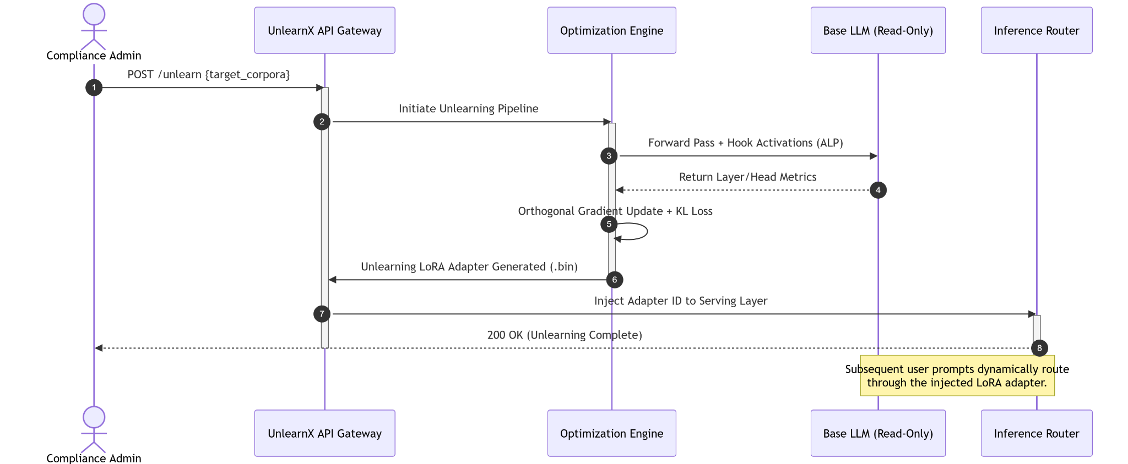est.

5. Scope of the Proof of Concept (PoC)
To ensure feasible delivery within the proposed 8-month timeline, the initial PoC will adhere to the following boundaries:
- Target Models: Mid-sized, open-weight models ranging from 1B to 8B parameters (e.g., Llama-3-8B, Mistral-7B).
- Data Sources: TOFU (Task of Fictitious Unlearning) benchmark, WMDP dataset, and subsets of the Books3 corpus.
- Tech Stack: PyTorch, Hugging Face Transformers/PEFT, and vLLM for the serving router simulation.
- Out of Scope (Phase 1): Multi-modal data unlearning (video/audio), massive models (70B+ parameters), and edge-device deployment.

6. Key Performance Indicators (KPIs)
The success of the UnlearnX PoC will be objectively measured against the following metrics:
- Forget Quality (Security):
  - Metric: Resistance to Membership Inference Attacks (MIA).
  - Target: The model's response to adversarial jailbreaks on forgotten data must be statistically indistinguishable from a model that never saw the data.
- Retain Utility (Performance):
  - Metric: Massive Multitask Language Understanding (MMLU) score.
  - Target: < 1% degradation in MMLU scores compared to the pre-unlearned base model.
- Operational Efficiency:
  - Metric: End-to-end latency per unlearning request.
  - Target: Generation and injection of the Unlearning LoRA within 300 seconds for a 1MB text corpus.

